**ADVANCED JAVA PRACTICAL 4 : QUIZ**

**Abdul shaikh :4528**

**Source code (Registration page):**

package quizardry;

import java.sql.*;

import javax.swing.JOptionPane;

/**

*

* @author AbdulRasool

*/

public class login extends javax.swing.JFrame {

/**

* Creates new form login

*/

public login() {

initComponents();

}

/**

* This method is called from within the constructor to initialize the form.

* WARNING: Do NOT modify this code. The content of this method is always

* regenerated by the Form Editor.

*/

@SuppressWarnings("unchecked")

// <editor-fold defaultstate="collapsed" desc="Generated Code">

private void initComponents() {

jLabel2 = new javax.swing.JLabel();

jLabel3 = new javax.swing.JLabel();

loguser = new javax.swing.JTextField();

logpass = new javax.swing.JPasswordField();

jLabel4 = new javax.swing.JLabel();

jButton1 = new javax.swing.JButton();

login = new javax.swing.JButton();

jLabel5 = new javax.swing.JLabel();

jLabel6 = new javax.swing.JLabel();

jLabel7 = new javax.swing.JLabel();

setDefaultCloseOperation(javax.swing.WindowConstants.EXIT_ON_CLOSE);

getContentPane().setLayout(new org.netbeans.lib.awtextra.AbsoluteLayout());

jLabel2.setFont(new java.awt.Font("Times New Roman", 1, 18)); // NOI18N

jLabel2.setForeground(new java.awt.Color(255, 255, 153));

jLabel2.setText("Password");

getContentPane().add(jLabel2, new org.netbeans.lib.awtextra.AbsoluteConstraints(190, 200, -1, -1));

jLabel3.setFont(new java.awt.Font("Times New Roman", 1, 18)); // NOI18N

jLabel3.setForeground(new java.awt.Color(255, 255, 153));

jLabel3.setText("Username");

getContentPane().add(jLabel3, new org.netbeans.lib.awtextra.AbsoluteConstraints(190, 130, -1, 30));

getContentPane().add(loguser, new org.netbeans.lib.awtextra.AbsoluteConstraints(290, 130, 200, 30));

getContentPane().add(logpass, new org.netbeans.lib.awtextra.AbsoluteConstraints(290, 190, 200, 30));

jLabel4.setFont(new java.awt.Font("Times New Roman", 1, 18)); // NOI18N

jLabel4.setForeground(new java.awt.Color(255, 255, 102));

jLabel4.setText("Register for Quiz !");

getContentPane().add(jLabel4, new org.netbeans.lib.awtextra.AbsoluteConstraints(200, 280, 160, 50));

jButton1.setBackground(new java.awt.Color(255, 255, 153));

jButton1.setFont(new java.awt.Font("Times New Roman", 1, 14)); // NOI18N

jButton1.setText("Register");

jButton1.setCursor(new java.awt.Cursor(java.awt.Cursor.HAND_CURSOR));

jButton1.addActionListener(new java.awt.event.ActionListener() {

public void actionPerformed(java.awt.event.ActionEvent evt) {

jButton1ActionPerformed(evt);

}

});

getContentPane().add(jButton1, new org.netbeans.lib.awtextra.AbsoluteConstraints(350, 290, 140, 30));

login.setBackground(new java.awt.Color(255, 255, 153));

login.setFont(new java.awt.Font("Times New Roman", 1, 18)); // NOI18N

login.setText("Login");

login.addActionListener(new java.awt.event.ActionListener() {

public void actionPerformed(java.awt.event.ActionEvent evt) {

loginActionPerformed(evt);

}

});

getContentPane().add(login, new org.netbeans.lib.awtextra.AbsoluteConstraints(200, 240, 290, 30));

jLabel5.setFont(new java.awt.Font("Constantia", 3, 20)); // NOI18N

jLabel5.setForeground(new java.awt.Color(255, 255, 102));

jLabel5.setText("Welcome to Quizardry! ");

getContentPane().add(jLabel5, new org.netbeans.lib.awtextra.AbsoluteConstraints(220, 10, -1, -1));

jLabel6.setFont(new java.awt.Font("Mongolian Baiti", 1, 20)); // NOI18N

jLabel6.setForeground(new java.awt.Color(102, 255, 204));

jLabel6.setText("Enter your credentials");

getContentPane().add(jLabel6, new org.netbeans.lib.awtextra.AbsoluteConstraints(240, 80, -1, -1));

jLabel7.setIcon(new javax.swing.ImageIcon(getClass().getResource("/quizardry/quizbg (1).jpg"))); // NOI18N

jLabel7.setText("jLabel7");

getContentPane().add(jLabel7, new org.netbeans.lib.awtextra.AbsoluteConstraints(0, 0, 600, 400));

pack();

}// </editor-fold>

private void jButton1ActionPerformed(java.awt.event.ActionEvent evt) {

// TODO add your handling code here:

this.dispose();

new registration().setVisible(true);

}

private void loginActionPerformed(java.awt.event.ActionEvent evt) {

// TODO add your handling code here:

String u = loguser.getText();

String queryname = "'"+loguser.getText()+"'";

char[] c = logpass.getPassword();

String p = String.valueOf(c);

try{

Connection con;

Class.forName("com.mysql.cj.jdbc.Driver");

String url = "jdbc:mysql://localhost:3307/quiz";

String user ="root";

String pass ="root";

con = DriverManager.getConnection(url,user,pass);

Statement st = con.createStatement();

String query = "select user,pass from data where user="+queryname+"";

ResultSet rst = st.executeQuery(query);

boolean flag = rst.next();

if(flag == true){

String uname = rst.getString(1);

String passs = rst.getString(2);

System.out.println(u);

System.out.println(p);

System.out.println(uname);

System.out.println(passs);

if(u.equals(uname) && p.equals(passs)){

JOptionPane.showMessageDialog(this,"Logged in succesfully!");

this.dispose();

new start(u);

new start(u).setVisible(true);

}

else{

JOptionPane.showMessageDialog(this,"Invalid Credentials!");

}

}

else {

JOptionPane.showMessageDialog(this,"We dont have any user registered with this username");

}

}

catch(Exception e){

e.printStackTrace();

}

}

/**

* @param args the command line arguments

*/

public static void main(String args[]) {

/* Set the Nimbus look and feel */

//<editor-fold defaultstate="collapsed" desc=" Look and feel setting code (optional) ">

/* If Nimbus (introduced in Java SE 6) is not available, stay with the default look and feel.

* For details see http://download.oracle.com/javase/tutorial/uiswing/lookandfeel/plaf.html

*/

try {

for (javax.swing.UIManager.LookAndFeelInfo info : javax.swing.UIManager.getInstalledLookAndFeels()) {

if ("Nimbus".equals(info.getName())) {

javax.swing.UIManager.setLookAndFeel(info.getClassName());

break;

}

}

} catch (ClassNotFoundException ex) {

java.util.logging.Logger.getLogger(login.class.getName()).log(java.util.logging.Level.SEVERE, null, ex);

} catch (InstantiationException ex) {

java.util.logging.Logger.getLogger(login.class.getName()).log(java.util.logging.Level.SEVERE, null, ex);

} catch (IllegalAccessException ex) {

java.util.logging.Logger.getLogger(login.class.getName()).log(java.util.logging.Level.SEVERE, null, ex);

} catch (javax.swing.UnsupportedLookAndFeelException ex) {

java.util.logging.Logger.getLogger(login.class.getName()).log(java.util.logging.Level.SEVERE, null, ex);

}

//</editor-fold>

/* Create and display the form */

java.awt.EventQueue.invokeLater(new Runnable() {

public void run() {

new login().setVisible(true);

}

});

}

// Variables declaration - do not modify

private javax.swing.JButton jButton1;

private javax.swing.JLabel jLabel2;

private javax.swing.JLabel jLabel3;

private javax.swing.JLabel jLabel4;

private javax.swing.JLabel jLabel5;

private javax.swing.JLabel jLabel6;

private javax.swing.JLabel jLabel7;

private javax.swing.JButton login;

private javax.swing.JPasswordField logpass;

public javax.swing.JTextField loguser;

// End of variables declaration

}

**Source code (Login page):**

/*

* Click nbfs://nbhost/SystemFileSystem/Templates/Licenses/license-default.txt to change this license

* Click nbfs://nbhost/SystemFileSystem/Templates/GUIForms/JFrame.java to edit this template

*/

package quizardry;

import java.sql.*;

import javax.swing.JOptionPane;

/**

*

* @author AbdulRasool

*/

public class login extends javax.swing.JFrame {

/**

* Creates new form login

*/

public login() {

initComponents();

}

/**

* This method is called from within the constructor to initialize the form.

* WARNING: Do NOT modify this code. The content of this method is always

* regenerated by the Form Editor.

*/

@SuppressWarnings("unchecked")

// <editor-fold defaultstate="collapsed" desc="Generated Code">

private void initComponents() {

jLabel2 = new javax.swing.JLabel();

jLabel3 = new javax.swing.JLabel();

loguser = new javax.swing.JTextField();

logpass = new javax.swing.JPasswordField();

jLabel4 = new javax.swing.JLabel();

jButton1 = new javax.swing.JButton();

login = new javax.swing.JButton();

jLabel5 = new javax.swing.JLabel();

jLabel6 = new javax.swing.JLabel();

jLabel7 = new javax.swing.JLabel();

setDefaultCloseOperation(javax.swing.WindowConstants.EXIT_ON_CLOSE);

getContentPane().setLayout(new org.netbeans.lib.awtextra.AbsoluteLayout());

jLabel2.setFont(new java.awt.Font("Times New Roman", 1, 18)); // NOI18N

jLabel2.setForeground(new java.awt.Color(255, 255, 153));

jLabel2.setText("Password");

getContentPane().add(jLabel2, new org.netbeans.lib.awtextra.AbsoluteConstraints(190, 200, -1, -1));

jLabel3.setFont(new java.awt.Font("Times New Roman", 1, 18)); // NOI18N

jLabel3.setForeground(new java.awt.Color(255, 255, 153));

jLabel3.setText("Username");

getContentPane().add(jLabel3, new org.netbeans.lib.awtextra.AbsoluteConstraints(190, 130, -1, 30));

getContentPane().add(loguser, new org.netbeans.lib.awtextra.AbsoluteConstraints(290, 130, 200, 30));

getContentPane().add(logpass, new org.netbeans.lib.awtextra.AbsoluteConstraints(290, 190, 200, 30));

jLabel4.setFont(new java.awt.Font("Times New Roman", 1, 18)); // NOI18N

jLabel4.setForeground(new java.awt.Color(255, 255, 102));

jLabel4.setText("Register for Quiz !");

getContentPane().add(jLabel4, new org.netbeans.lib.awtextra.AbsoluteConstraints(200, 280, 160, 50));

jButton1.setBackground(new java.awt.Color(255, 255, 153));

jButton1.setFont(new java.awt.Font("Times New Roman", 1, 14)); // NOI18N

jButton1.setText("Register");

jButton1.setCursor(new java.awt.Cursor(java.awt.Cursor.HAND_CURSOR));

jButton1.addActionListener(new java.awt.event.ActionListener() {

public void actionPerformed(java.awt.event.ActionEvent evt) {

jButton1ActionPerformed(evt);

}

});

getContentPane().add(jButton1, new org.netbeans.lib.awtextra.AbsoluteConstraints(350, 290, 140, 30));

login.setBackground(new java.awt.Color(255, 255, 153));

login.setFont(new java.awt.Font("Times New Roman", 1, 18)); // NOI18N

login.setText("Login");

login.addActionListener(new java.awt.event.ActionListener() {

public void actionPerformed(java.awt.event.ActionEvent evt) {

loginActionPerformed(evt);

}

});

getContentPane().add(login, new org.netbeans.lib.awtextra.AbsoluteConstraints(200, 240, 290, 30));

jLabel5.setFont(new java.awt.Font("Constantia", 3, 20)); // NOI18N

jLabel5.setForeground(new java.awt.Color(255, 255, 102));

jLabel5.setText("Welcome to Quizardry! ");

getContentPane().add(jLabel5, new org.netbeans.lib.awtextra.AbsoluteConstraints(220, 10, -1, -1));

jLabel6.setFont(new java.awt.Font("Mongolian Baiti", 1, 20)); // NOI18N

jLabel6.setForeground(new java.awt.Color(102, 255, 204));

jLabel6.setText("Enter your credentials");

getContentPane().add(jLabel6, new org.netbeans.lib.awtextra.AbsoluteConstraints(240, 80, -1, -1));

jLabel7.setIcon(new javax.swing.ImageIcon(getClass().getResource("/quizardry/quizbg (1).jpg"))); // NOI18N

jLabel7.setText("jLabel7");

getContentPane().add(jLabel7, new org.netbeans.lib.awtextra.AbsoluteConstraints(0, 0, 600, 400));

pack();

}// </editor-fold>

private void jButton1ActionPerformed(java.awt.event.ActionEvent evt) {

// TODO add your handling code here:

this.dispose();

new registration().setVisible(true);

}

private void loginActionPerformed(java.awt.event.ActionEvent evt) {

// TODO add your handling code here:

String u = loguser.getText();

String queryname = "'"+loguser.getText()+"'";

char[] c = logpass.getPassword();

String p = String.valueOf(c);

try{

Connection con;

Class.forName("com.mysql.cj.jdbc.Driver");

String url = "jdbc:mysql://localhost:3307/quiz";

String user ="root";

String pass ="root";

con = DriverManager.getConnection(url,user,pass);

Statement st = con.createStatement();

String query = "select user,pass from data where user="+queryname+"";

ResultSet rst = st.executeQuery(query);

boolean flag = rst.next();

if(flag == true){

String uname = rst.getString(1);

String passs = rst.getString(2);

System.out.println(u);

System.out.println(p);

System.out.println(uname);

System.out.println(passs);

if(u.equals(uname) && p.equals(passs)){

JOptionPane.showMessageDialog(this,"Logged in succesfully!");

this.dispose();

new start(u);

new start(u).setVisible(true);

}

else{

JOptionPane.showMessageDialog(this,"Invalid Credentials!");

}

}

else {

JOptionPane.showMessageDialog(this,"We dont have any user registered with this username");

}

}

catch(Exception e){

e.printStackTrace();

}

}

/**

* @param args the command line arguments

*/

public static void main(String args[]) {

/* Set the Nimbus look and feel */

//<editor-fold defaultstate="collapsed" desc=" Look and feel setting code (optional) ">

/* If Nimbus (introduced in Java SE 6) is not available, stay with the default look and feel.

* For details see http://download.oracle.com/javase/tutorial/uiswing/lookandfeel/plaf.html

*/

try {

for (javax.swing.UIManager.LookAndFeelInfo info : javax.swing.UIManager.getInstalledLookAndFeels()) {

if ("Nimbus".equals(info.getName())) {

javax.swing.UIManager.setLookAndFeel(info.getClassName());

break;

}

}

} catch (ClassNotFoundException ex) {

java.util.logging.Logger.getLogger(login.class.getName()).log(java.util.logging.Level.SEVERE, null, ex);

} catch (InstantiationException ex) {

java.util.logging.Logger.getLogger(login.class.getName()).log(java.util.logging.Level.SEVERE, null, ex);

} catch (IllegalAccessException ex) {

java.util.logging.Logger.getLogger(login.class.getName()).log(java.util.logging.Level.SEVERE, null, ex);

} catch (javax.swing.UnsupportedLookAndFeelException ex) {

java.util.logging.Logger.getLogger(login.class.getName()).log(java.util.logging.Level.SEVERE, null, ex);

}

//</editor-fold>

/* Create and display the form */

java.awt.EventQueue.invokeLater(new Runnable() {

public void run() {

new login().setVisible(true);

}

});

}

// Variables declaration - do not modify

private javax.swing.JButton jButton1;

private javax.swing.JLabel jLabel2;

private javax.swing.JLabel jLabel3;

private javax.swing.JLabel jLabel4;

private javax.swing.JLabel jLabel5;

private javax.swing.JLabel jLabel6;

private javax.swing.JLabel jLabel7;

private javax.swing.JButton login;

private javax.swing.JPasswordField logpass;

public javax.swing.JTextField loguser;

// End of variables declaration

}

**Source code: Start quiz**

/*

* Click nbfs://nbhost/SystemFileSystem/Templates/Licenses/license-default.txt to change this license

* Click nbfs://nbhost/SystemFileSystem/Templates/GUIForms/JFrame.java to edit this template

*/

package quizardry;

/**

*

* @author AbdulRasool

*/

public class start extends javax.swing.JFrame {

static String username;

/**

* Creates new form start

*/

public start(String username) {

this.username = username;

initComponents();

gamename.setBackground(new java.awt.Color(0,0,0,1));

}

/**

* This method is called from within the constructor to initialize the form.

* WARNING: Do NOT modify this code. The content of this method is always

* regenerated by the Form Editor.

*/

@SuppressWarnings("unchecked")

// <editor-fold defaultstate="collapsed" desc="Generated Code">

private void initComponents() {

gamename = new javax.swing.JTextField();

jLabel1 = new javax.swing.JLabel();

enter = new javax.swing.JButton();

jLabel2 = new javax.swing.JLabel();

setDefaultCloseOperation(javax.swing.WindowConstants.EXIT_ON_CLOSE);

getContentPane().setLayout(new org.netbeans.lib.awtextra.AbsoluteLayout());

gamename.setFont(new java.awt.Font("Times New Roman", 1, 18)); // NOI18N

gamename.setForeground(new java.awt.Color(102, 255, 255));

getContentPane().add(gamename, new org.netbeans.lib.awtextra.AbsoluteConstraints(210, 260, 160, 30));

jLabel1.setFont(new java.awt.Font("Constantia", 3, 18)); // NOI18N

jLabel1.setForeground(new java.awt.Color(255, 0, 255));

jLabel1.setText("Enter game name:");

getContentPane().add(jLabel1, new org.netbeans.lib.awtextra.AbsoluteConstraints(50, 260, -1, 40));

enter.setBackground(new java.awt.Color(27, 249, 249));

enter.setFont(new java.awt.Font("Mongolian Baiti", 1, 18)); // NOI18N

enter.setText("Enter");

enter.addActionListener(new java.awt.event.ActionListener() {

public void actionPerformed(java.awt.event.ActionEvent evt) {

enterActionPerformed(evt);

}

});

getContentPane().add(enter, new org.netbeans.lib.awtextra.AbsoluteConstraints(170, 300, 100, -1));

jLabel2.setIcon(new javax.swing.ImageIcon(getClass().getResource("/quizardry/quizstart.jpg"))); // NOI18N

jLabel2.setText("jLabel2");

getContentPane().add(jLabel2, new org.netbeans.lib.awtextra.AbsoluteConstraints(0, 0, 440, 350));

pack();

}// </editor-fold>

private void enterActionPerformed(java.awt.event.ActionEvent evt) {

// TODO add your handling code here:

this.dispose();

String name = gamename.getText();

new mainClass(name , username);

System.out.println(username);

}

/**

* @param args the command line arguments

*/

public static void main(String args[]) {

/* Set the Nimbus look and feel */

//<editor-fold defaultstate="collapsed" desc=" Look and feel setting code (optional) ">

/* If Nimbus (introduced in Java SE 6) is not available, stay with the default look and feel.

* For details see http://download.oracle.com/javase/tutorial/uiswing/lookandfeel/plaf.html

*/

try {

for (javax.swing.UIManager.LookAndFeelInfo info : javax.swing.UIManager.getInstalledLookAndFeels()) {

if ("Nimbus".equals(info.getName())) {

javax.swing.UIManager.setLookAndFeel(info.getClassName());

break;

}

}

} catch (ClassNotFoundException ex) {

java.util.logging.Logger.getLogger(start.class.getName()).log(java.util.logging.Level.SEVERE, null, ex);

} catch (InstantiationException ex) {

java.util.logging.Logger.getLogger(start.class.getName()).log(java.util.logging.Level.SEVERE, null, ex);

} catch (IllegalAccessException ex) {

java.util.logging.Logger.getLogger(start.class.getName()).log(java.util.logging.Level.SEVERE, null, ex);

} catch (javax.swing.UnsupportedLookAndFeelException ex) {

java.util.logging.Logger.getLogger(start.class.getName()).log(java.util.logging.Level.SEVERE, null, ex);

}

//</editor-fold>

/* Create and display the form */

java.awt.EventQueue.invokeLater(new Runnable() {

public void run() {

new start(username).setVisible(true);

}

});

}

// Variables declaration - do not modify

private javax.swing.JButton enter;

public javax.swing.JTextField gamename;

private javax.swing.JLabel jLabel1;

private javax.swing.JLabel jLabel2;

// End of variables declaration

}

**Source code: Mainclass {Main quiz}**

/*

* Click nbfs://nbhost/SystemFileSystem/Templates/Licenses/license-default.txt to change this license

* Click nbfs://nbhost/SystemFileSystem/Templates/Classes/Class.java to edit this template

*/

package quizardry;

import java.awt.Color;

import java.awt.Font;

import java.awt.Graphics;

import java.awt.event.ActionEvent;

import java.awt.event.ActionListener;

import java.util.Arrays;

import javax.swing.BorderFactory;

import javax.swing.ButtonGroup;

import javax.swing.ImageIcon;

import javax.swing.JButton;

import javax.swing.JFrame;

import javax.swing.JLabel;

import javax.swing.JRadioButton;

import javax.swing.JTextArea;

import java.sql.*;

import javax.swing.JOptionPane;

/**

*

* @author AbdulRasool

*/

public class mainClass extends JFrame implements ActionListener{

public static int count = 0;

public static int ans_selected = 0;

public static int score = 0;

public static int timer = 20;

ButtonGroup group;

String name;

String username;

JLabel qno,welcome;

JTextArea question;

JButton next ,submit ,lifeline;

JRadioButton opt1,opt2,opt3,opt4;

String questions[][] = new String[10][5];

String useranswer[][] = new String[10][1];

String answers [][] = new String [10][2];

mainClass(String name , String username){

questions[0][0] = "Which is used to find and fix "

+ "bugs in the Java programs.?"

+ "";

questions[0][1] = "JVM";

questions[0][2] = "JDB";

questions[0][3] = "JDK";

questions[0][4] = "JRE";

questions[1][0] = "What is the return type of the hashCode() method in the Object class?";

questions[1][1] = "int";

questions[1][2] = "Object";

questions[1][3] = "long";

questions[1][4] = "void";

questions[2][0] = "Which package contains the Random class?";

questions[2][1] = "java.util package";

questions[2][2] = "java.lang package";

questions[2][3] = "java.awt package";

questions[2][4] = "java.io package";

questions[3][0] = "An interface with no fields or methods is known as?";

questions[3][1] = "Runnable Interface";

questions[3][2] = "Abstract Interface";

questions[3][3] = "Marker Interface";

questions[3][4] = "CharSequence Interface";

questions[4][0] = "In which memory a String is stored, when we create a string using new operator?";

questions[4][1] = "Stack";

questions[4][2] = "String memory";

questions[4][3] = "Random storage space";

questions[4][4] = "Heap memory";

questions[5][0] = "Which of the following is a marker interface?";

questions[5][1] = "Runnable interface";

questions[5][2] = "Remote interface";

questions[5][3] = "Readable interface";

questions[5][4] = "Result interface";

questions[6][0] = "Which keyword is used for accessing the features of a package?";

questions[6][1] = "import";

questions[6][2] = "package";

questions[6][3] = "extends";

questions[6][4] = "export";

questions[7][0] = "In java, jar stands for?";

questions[7][1] = "Java Archive Runner";

questions[7][2] = "Java Archive";

questions[7][3] = "Java Application Resource";

questions[7][4] = "Java Application Runner";

questions[8][0] = "Which of the following is a mutable class in java?";

questions[8][1] = "java.lang.StringBuilder";

questions[8][2] = "java.lang.Short";

questions[8][3] = "java.lang.Byte";

questions[8][4] = "java.lang.String";

questions[9][0] = "Which of the following option leads to the portability and security of Java?";

questions[9][1] = "Bytecode is executed by JVM";

questions[9][2] = "The applet makes the Java code secure and portable";

questions[9][3] = "Use of exception handling";

questions[9][4] = "Dynamic binding between objects";

answers[0][1] = "JDB";

answers[1][1] = "int";

answers[2][1] = "java.util package";

answers[3][1] = "Marker Interface";

answers[4][1] = "Heap memory";

answers[5][1] = "Remote interface";

answers[6][1] = "import";

answers[7][1] = "Java Archive";

answers[8][1] = "java.lang.StringBuilder";

answers[9][1] = "Bytecode is executed by JVM";

this.name = name;

this.username = username;

setSize(540,400);

//getContentPane().setBackground(Color.WHITE);

setLayout(null);

setVisible(true);

setDefaultCloseOperation(JFrame.EXIT_ON_CLOSE);

qno = new JLabel();

qno.setText("");

qno.setBounds(135,50,50,60);

qno.setFont(new Font("TimesNewRoman", Font.PLAIN, 15));

qno.setForeground(Color.WHITE);

question = new JTextArea();

question.setText("");

question.setBounds(160,90,280,50);

question.setFont(new Font("TimesNewRoman", Font.BOLD,17));

question.setBackground(new java.awt.Color(0,0,0,0));

question.setForeground(Color.WHITE);

question.setLineWrap(true);

question.setWrapStyleWord(true);

question.setEditable(false);

question.setBorder(null);

add(qno);

add(question);

welcome = new JLabel("Welcome, "+name);

welcome.setBounds(20,10,400,30);

welcome.setFont(new Font("TimesNewRoman", Font.BOLD,18));

welcome.setBackground(new java.awt.Color(0,0,0,0));

welcome.setForeground(Color.WHITE);

add(welcome);

next = new JButton("Next");

next.setBounds(90,310,100,30); //x,y,width,height

next.setFont(new Font("Tahoma", Font.PLAIN, 22));

next.setBackground(new java.awt.Color(0,0,0,0));

next.setOpaque(false);

next.setForeground(Color.WHITE);

next.setBorder(BorderFactory.createBevelBorder(1, Color.pink, Color.cyan));

next.addActionListener(this);

add(next);

submit = new JButton("Submit");

submit.setBounds(200,310,100,30); //x,y,width,height

submit.setFont(new Font("Tahoma", Font.PLAIN, 22));

submit.setBackground(new java.awt.Color(0,0,0,0));

submit.setForeground(Color.WHITE);

submit.setBorder(BorderFactory.createBevelBorder(1, Color.cyan, Color.pink));

submit.setOpaque(false);

submit.addActionListener(this);

submit.setEnabled(false);

submit.setForeground(Color.decode("#9D9FA2"));

add(submit);

lifeline = new JButton("Lifeline");

lifeline.setBounds(310,310,100,30); //x,y,width,height

lifeline.setFont(new Font("Tahoma", Font.PLAIN, 22));

lifeline.setBackground(new java.awt.Color(0,0,0,0));

lifeline.setForeground(Color.WHITE);

lifeline.setBorder(BorderFactory.createBevelBorder(1, Color.pink, Color.cyan));

lifeline.addActionListener(this);

lifeline.setOpaque(false);

add(lifeline);

opt1 = new JRadioButton("");

opt1.setForeground(Color.WHITE);

opt1.setBounds(50,195,200,25);

opt1.setBackground(new java.awt.Color(0,0,0,0));

opt1.setFont(new Font("TimesNewRoman", Font.PLAIN, 18));

opt1.setOpaque(false);

add(opt1);

opt2 = new JRadioButton("");

opt2.setForeground(Color.WHITE);

opt2.setBounds(280,195,200,25);

opt2.setBackground(new java.awt.Color(0,0,0,0));

opt2.setFont(new Font("TimesNewRoman", Font.PLAIN, 18));

opt2.setOpaque(false);

add(opt2);

opt3 = new JRadioButton("");

opt3.setForeground(Color.WHITE);

opt3.setBounds(50,260,200,25);

opt3.setBackground(new java.awt.Color(0,0,0,0));

opt3.setFont(new Font("TimesNewRoman", Font.PLAIN, 18));

opt3.setOpaque(false);

add(opt3);

opt4 = new JRadioButton("");

opt4.setForeground(Color.WHITE);

opt4.setBounds(280,260,200,25);

opt4.setBackground(new java.awt.Color(0,0,0,0));

opt4.setFont(new Font("TimesNewRoman", Font.PLAIN, 18));

opt4.setOpaque(false);

add(opt4);

group = new ButtonGroup();

group.add(opt1);

group.add(opt2);

group.add(opt3);

group.add(opt4);

ImageIcon i1 = new ImageIcon(ClassLoader.getSystemResource("mainquizbg.jpg"));

JLabel image = new JLabel(i1);

image.setBounds(0, 0,540,360);

add(image);

start(count);

}

public void start(int count){

qno.setText(""+(count+1)+")");

question.setText(questions[count][0]);

opt1.setText(questions [count][1]);

opt1.setActionCommand(questions[count][1]);

opt2.setText(questions[count][2]);

opt2.setActionCommand(questions[count][2]);

opt3.setText(questions[count][3]);

opt3.setActionCommand(questions[count][3]);

opt4.setText(questions[count][4]);

opt4.setActionCommand(questions[count][4]);

group.clearSelection();

}

public static void main(String args[]){

new mainClass("User","User");

}

@Override

public void paint(Graphics g) {

super.paint(g);

String time = "Time left : " + timer + " seconds"; // 15

g.setFont(new Font("TimesNewRoman", Font.BOLD, 17));

if(timer == 0){

g.setColor(Color.RED);

g.drawString("TIMES UP!!!", 330, 65);

}

else if(timer < 5){

g.setColor(Color.RED);

g.drawString(time, 330, 65);

}

else{

g.setColor(Color.GREEN);

g.drawString(time, 330, 65);

}

if(ans_selected == 1){

timer = 20;

ans_selected = 0;

}

if(ans_selected == 0 && timer == 0){

useranswer[count][0] = "Not given";

timer = 20;

count++;

start(count);

}

if(count ==10){

setVisible(false);

}

timer--;

try{

Thread.sleep(1000);

repaint();

}catch(Exception e){

e.printStackTrace();

}

}

@Override

@SuppressWarnings("empty-statement")

public void actionPerformed(ActionEvent e) {

if(e.getSource() == next){

//repaint();

opt1.setEnabled(true);

opt1.setForeground(Color.decode("#FFFFFF"));

opt2.setEnabled(true);

opt2.setForeground(Color.decode("#FFFFFF"));

opt3.setEnabled(true);

opt3.setForeground(Color.decode("#FFFFFF"));

opt4.setEnabled(true);

opt4.setForeground(Color.decode("#FFFFFF"));

ans_selected = 1;

if(group.getSelection() == null){

useranswer[count][0] = "wronganswer";

}

else{

useranswer[count][0] = group.getSelection().getActionCommand();

}

if(count == 8){

submit.setEnabled(true);

submit.setForeground(Color.decode("#FFFFFF"));

next.setEnabled(false);

next.setForeground(Color.decode("#9D9FA2"));

}

count++;

start(count);

}

else if(e.getSource() == submit){

ans_selected = 1;

if(group.getSelection() == null){

useranswer[count][0] = "wronganswer";

}

else{

useranswer[count][0] = group.getSelection().getActionCommand();

}

for (int i = 0; i<useranswer.length; i++){

for(int j = 0; j<useranswer[i].length; j++){

System.out.println( useranswer [i][j]);

}

}

for(int i = 0; i<useranswer.length; i++){

if(useranswer[i][0].equals(answers[i][1])){

score+=10;

}

else{

score+=0;

}

System.out.println("Score is: "+score);

System.out.println(Arrays.toString(answers));

}

try{

Connection con;

Class.forName("com.mysql.cj.jdbc.Driver");

String url = "jdbc:mysql://localhost:3307/quiz";

String user ="root";

String pass ="root";

con = DriverManager.getConnection(url,user,pass);

String query = "INSERT INTO SCORE VALUES (?,?,?)";

PreparedStatement pst = con.prepareStatement(query);

login s = new login();

String g = s.loguser.getText();

pst.setString(1,g);

pst.setString(2,name);

pst.setInt(3,score);

pst.execute();

JOptionPane.showMessageDialog(this, "Your answers submitted Thanks for playing Quizardry");

}catch(Exception except){

except.printStackTrace();

}

}

else if (e.getSource() == lifeline)

{

if (count == 2 || count == 4 || count == 6 || count == 8 || count == 9)

{

opt2.setEnabled(false);

opt2.setForeground(Color.decode("#9D9FA2"));

opt3.setEnabled(false);

opt3.setForeground(Color.decode("#9D9FA2"));

}

else {

opt1.setEnabled(false);

opt1.setForeground(Color.decode("#9D9FA2"));

opt4.setEnabled(false);

opt4.setForeground(Color.decode("#9D9FA2"));

}

lifeline.setEnabled(false);

lifeline.setForeground(Color.decode("#9D9FA2"));

}

}

}

**Outputs**

**Registration Page:**

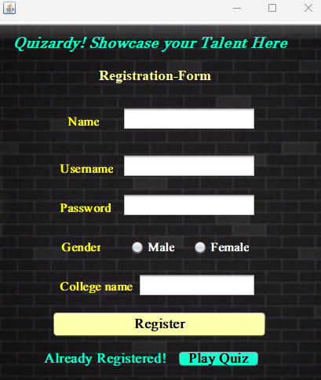

**Login Page:**

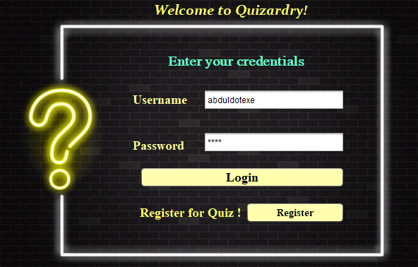

**Start quiz:**

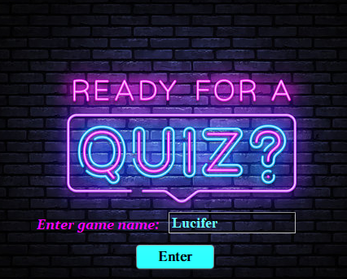

**Output Main quiz (After clicking on Enter) :**

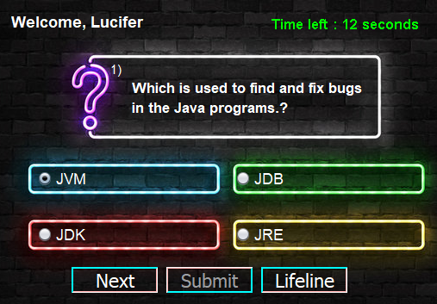

**When clicked on Next stores the selected answer and displays the next question if timer goes up it automatically shifts to the next question**

**When clicked on Lifeline**

**Disables two wrong options for you!**

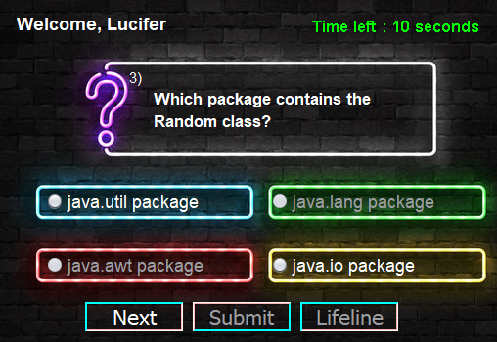

**On last question (Submit button enables and Next button disables):**

**After clicking on Submit :**

**(Displays the Message box thanking the user and Submits the answers to the MYSQL Database)**

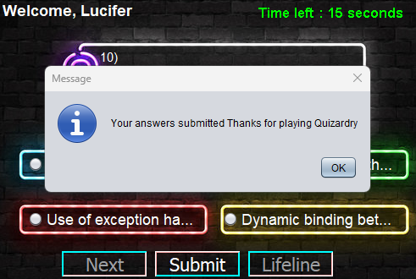

**MYSQL TABLE LOGIN (DATA)**

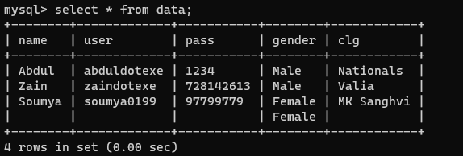

**MYSQL TABLE SCORE**

